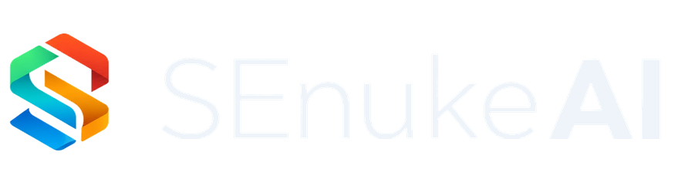
FOUNDING LAUNCH • PARTNER EDITORIAL COLLECTION
Nine Publication-Ready
Blog Posts
Category education, customer-specific growth stories and launch conversion content for approved SEnuke AI partners
Understand → Discover → Strategize → Approve → Execute → Measure → Learn → Next Best Action → Repeat
Public launch: September 8, 2026 | Founding Launch ends: September 15, 2026 at 11:59 PM ET

Publishing Instructions
This collection contains nine finished long-form articles for approved SEnuke AI JVs and affiliates. Each article includes SEO metadata, a matching hero image reference, internal-link suggestions and a launch CTA.
Affiliate link | Replace every {{AFFILIATE_LINK}} placeholder with your approved JVZoo affiliate link.
Hero image | Use the exact corresponding file in 03_BLOG_HERO_IMAGES.
Internal links | Update suggested slugs if your site uses a different URL structure.
Launch window | September 8, 2026 at 12:00 PM ET through September 15, 2026 at 11:59 PM ET.
Locked identity | SEnuke AI is THE AI GROWTH OPERATING SYSTEM.

Article Index
- What Is an AI Growth Operating System?
- Why More AI Tools Do Not Mean More Growth
- The Business Growth Question Most Platforms Cannot Answer
- How the Continuous Growth Loop Works
- From Idea or Expertise to a Business You Can Grow
- Why Established Businesses Need One Shared Growth System
- How Agencies Scale Clients Without Losing Control
- Ecommerce Growth Beyond More Listings and More Traffic
- Turning Evidence Into the Next Best Action

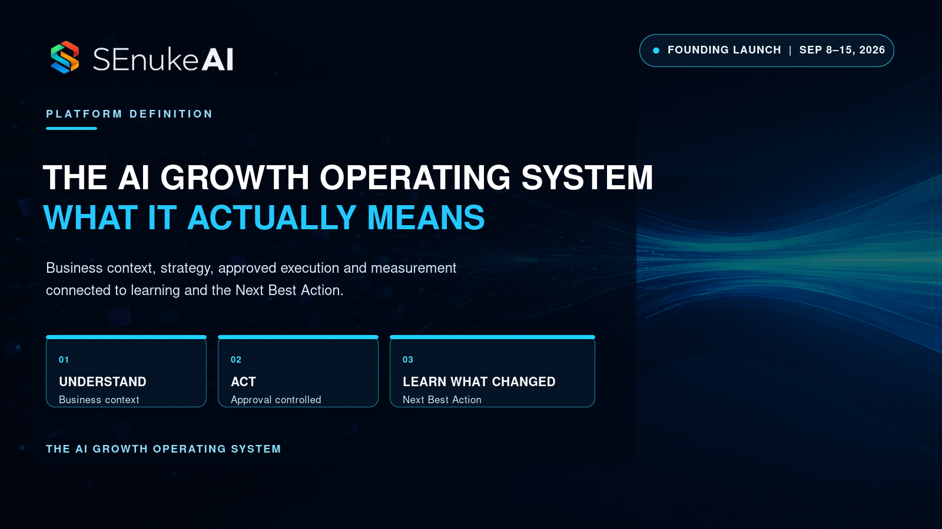
ARTICLE 01

What Is an AI Growth Operating System?
SEO title | What Is an AI Growth Operating System? A Practical Guide
Meta description | Learn what an AI Growth Operating System is, how it connects strategy, execution and learning, and why that changes the way businesses grow.
Suggested slug | /what-is-an-ai-growth-operating-system/
Hero image | BLOG-HERO-001_What-Is-An-AI-Growth-Operating-System_1600x900.png
Primary audience | Entrepreneurs, business owners, agencies and consultants
Affiliate CTA | Replace `{{AFFILIATE_LINK}}` with your approved SEnuke AI JVZoo affiliate link before publishing.

Most businesses do not have an information problem. They have a coordination problem.
They can find an SEO tool to report rankings, an analytics platform to show traffic, an AI writer to create copy, a project system to assign tasks and a dashboard to display results. Each tool may do its own job well. The problem appears in the space between them.
Who decides what matters most? Which opportunity deserves time and budget now? How does a finding become an approved action? What happens after the work is completed? And who turns the result into a better decision?
That is the gap an AI Growth Operating System is designed to close.

A growth operating system is more than another AI tool
An ordinary AI tool usually begins with a request. You ask for an analysis, a plan, a page or a piece of content. It produces an answer and waits for the next prompt.
An AI Growth Operating System begins somewhere more useful: with the business itself.
It builds and preserves the context behind the work, including the audience, offer, goals, market, competitors, assets, constraints, previous decisions and available evidence. It then connects discovery, strategy, approved execution, measurement and learning inside one guided process.
That difference matters because a plausible answer is not necessarily the right next move for a specific business.
A company with weak conversion does not automatically need more traffic. A store with strong products but confusing categories may not need another promotion. An agency client whose campaign appears flat may first need a data connection repaired before any reliable conclusion can be made.
The system must understand the situation before it can recommend what deserves priority.

The question at the center of the system
The most valuable business question is often not “What can AI create?”
It is:
What should this business do next?
Answering that responsibly requires more than generating a task. The recommendation should reflect the business context, approved Strategy, available evidence, completed work, current results, dependencies, effort, cost, risk and required approvals.
When several opportunities are valid, the system should compare them and identify the strongest current Next Best Action. The remaining opportunities should not disappear. They should remain connected to the Strategy or Execution Plan until their priority changes.
When the evidence is incomplete, the right action may be to connect a source, refresh an analysis, confirm a business assumption or request approval. A useful operating system does not manufacture confidence. It makes the evidence gap visible and guides the user toward resolving it.

The Continuous Growth Loop
SEnuke AI organizes growth around a connected loop:
Understand → Discover → Strategize → Approve → Execute → Measure → Learn → Next Best Action → Repeat
Each stage solves a different failure point in the way businesses often approach growth.

Understand
The system establishes the Business Brain: what the business does, who it serves, what it offers, what it wants to achieve and what constraints shape the decision.

Discover
It examines customers, markets, competitors, search intent, websites, offers, conversion paths, ecommerce opportunities and other relevant evidence to find risks and opportunities.

Strategize
It turns those findings into an ordered growth direction instead of presenting a pile of disconnected recommendations.

Approve
The user reviews the work, revises it where necessary and controls which version can move forward. Material live actions remain governed by permissions and approval.

Execute
Approved priorities become work with tasks, dependencies, owners, status and implementation paths. Where a supported connection exists, approved work can move toward that destination. Otherwise, the system provides a clear handoff for manual implementation.

Measure and learn
The system evaluates the available results, compares them with previous evidence and records what changed. That learning affects what should happen next.

Next Best Action and repeat
The current priority is retained, updated or replaced as the business and evidence change. Growth becomes an operating rhythm rather than a collection of campaigns that forget what happened before.

Guidance without surrendering control
Guided does not mean uncontrolled.
An AI Growth Operating System should explain what it found, why it matters, what it recommends, why the recommendation has been prioritized and what evidence supports it. Where relevant, it should also make confidence, effort, cost, risk, dependencies and capacity requirements visible.
But a recommendation is not permission for the platform to make every material change on its own.
Publishing, website changes, listing changes, outreach and other reputation-sensitive external actions still require the appropriate user approval, role and permission. Only the approved version should move forward where approval is required.
This combination is important: the customer receives decisive guidance without losing control of the business.

One system, three operating models
The same core system can serve very different users because the essential growth problem remains the same. An Entrepreneur may begin with an idea or their existing expertise. A Business can coordinate evidence, people and approved work. An Agency can give each client an isolated growth system through an Agency → Client → Project structure.
Ecommerce is available across every workspace. That includes intelligence for store owners and third-party sellers who need clearer product, category, buyer-intent, merchandising and conversion priorities.
Every SEnuke AI plan includes the complete core AI Growth Operating System. The plans differ in AI Capacity and the operating structure required for an individual owner, a business team or a client-service organization.
The practical difference is continuity. A finding can shape the Strategy, the Strategy can guide approved work, completed work can be measured and new evidence can change the priority. The business does not have to restart the reasoning process every time it opens another tool.

The next era of business AI will be connected
Businesses already have access to more AI output than they can use. The greater opportunity is to make business context, evidence, decisions, execution and learning work together.
That is what an AI Growth Operating System is built to do.
SEnuke AI is THE AI GROWTH OPERATING SYSTEM. It helps the customer understand the situation, validate the relevant available evidence and see the current Next Best Action without giving up approval or control.
Founding Launch: SEnuke AI opens September 8, 2026 at 12:00 PM ET. Founding Launch pricing ends September 15, 2026 at 11:59 PM ET. Explore SEnuke AI through your approved partner link.
Related reading: Why More AI Tools Do Not Mean More Growth · How the Continuous Growth Loop Works · Turning Evidence Into the Next Best Action

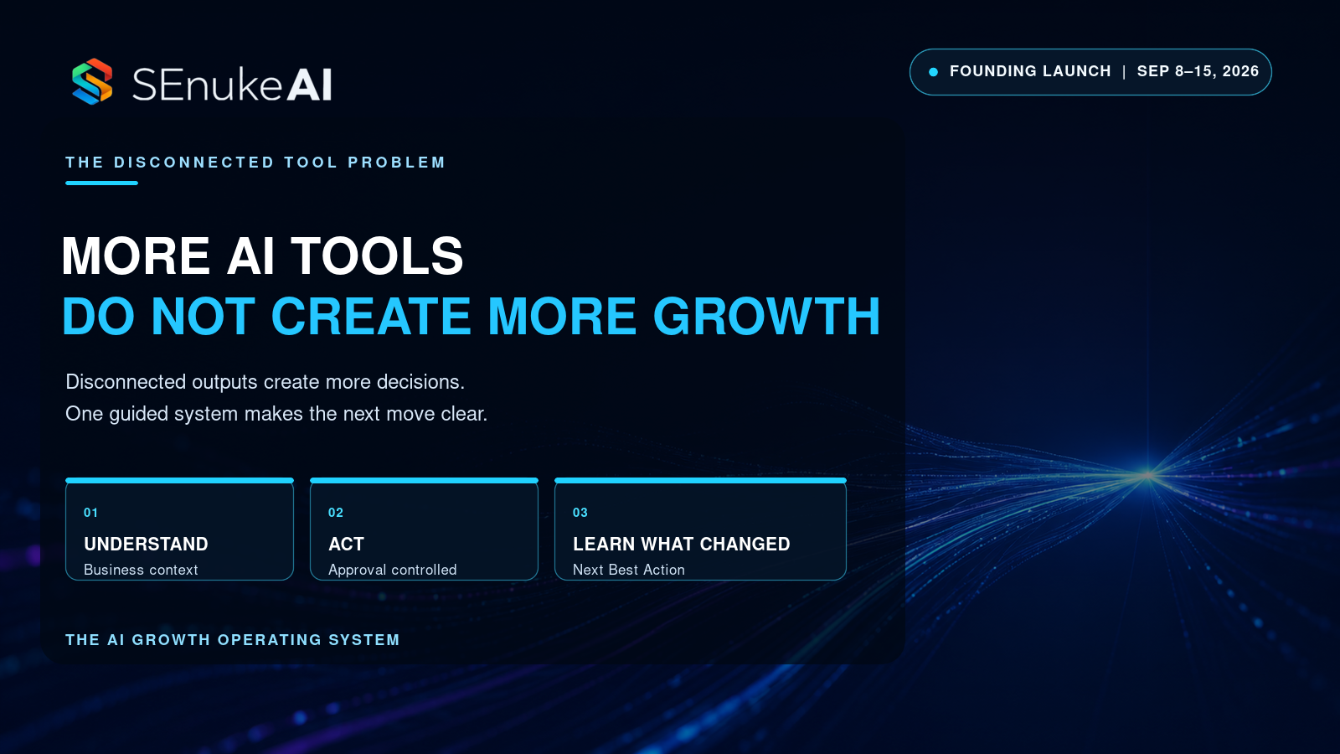
ARTICLE 02

Why More AI Tools Do Not Mean More Growth
SEO title | Why More AI Tools Do Not Mean More Business Growth
Meta description | More AI tools can create more output without producing growth. Learn why connected context, priorities, execution and learning matter more.
Suggested slug | /why-more-ai-tools-do-not-mean-more-growth/
Hero image | BLOG-HERO-002_Why-More-AI-Tools-Do-Not-Mean-More-Growth_1600x900.png
Primary audience | Entrepreneurs, business leaders and marketing teams
Affiliate CTA | Replace `{{AFFILIATE_LINK}}` with your approved SEnuke AI JVZoo affiliate link before publishing.

It has never been easier to create a marketing plan, write an article, analyze a page or generate a list of ideas.
It has also never been easier to become buried under work that looks productive but does not move the business forward.
The modern AI stack can produce more suggestions in an afternoon than a small team could complete in a quarter. That abundance feels like progress. Often it is simply a larger decision problem.
More tools do not automatically create more growth because growth does not come from output alone. It comes from choosing the right problem, acting on the right priority, measuring what changed and using the result to make a better decision.

Tool accumulation creates a hidden management burden
Every specialized tool creates a new source of information.
One identifies keyword opportunities. Another audits the website. Another produces content. Another tracks conversions. Another holds tasks. Another summarizes meetings. Each one can generate a valid recommendation within its own field of view.
The business owner or marketing leader is left to solve the harder problem:
- Which source should be trusted?
- Which finding is current?
- Which recommendation supports the actual business goal?
- Which opportunity has already been addressed?
- Which task depends on another task?
- Which action has enough evidence to justify the cost?
- What should the team stop doing to make room for the new priority?
The more tools a business adds, the more coordination it must perform outside those tools.
That work is rarely visible on a dashboard, but it consumes attention, creates delay and increases the chance that a persuasive suggestion will be mistaken for the most important one.

Output is not the same as progress
AI is very good at making activity feel tangible.
A list of 100 content ideas looks valuable. A 40-page audit feels comprehensive. A new landing page creates a sense of movement. Yet none of these tells the business whether the work is necessary now.
Imagine an established service company with healthy website traffic but a weak enquiry path. Producing more articles may increase activity while leaving the actual constraint untouched. The stronger move could be to clarify the offer, repair the conversion path or strengthen the evidence prospects need before contacting the company.
The problem is not that content is unimportant. The problem is sequence.
Useful work performed at the wrong time can still waste time and money.

Disconnected AI forgets the business between prompts
Most AI interactions begin with whatever context the user remembers to include.
That makes the answer dependent on the prompt rather than the complete business situation. The model may not know that the team rejected a similar idea last month, that the offer is changing, that a data source is stale, that a page is already being rebuilt or that another action has higher expected impact.
Without shared context, every tool solves a slightly different version of the business.
A connected growth system preserves the Business Brain: the audience, offer, goals, market, competitors, assets, decisions, constraints and evidence behind the work. That context can then shape research, strategy, execution and measurement instead of being recreated imperfectly for every task.

The missing layer is prioritization
Businesses rarely suffer from having no possible next move. They suffer from having too many.
Prioritization should be more rigorous than choosing the idea that sounds exciting. A defensible priority considers factors such as:
- expected impact;
- strength and freshness of the evidence;
- fit with the approved Strategy;
- effort and cost;
- urgency;
- dependencies;
- operational risk;
- available capacity;
- required permissions and approval.
The strongest action may be a major opportunity. It may also be a prerequisite that makes later action reliable.
If conversion data is disconnected, the current Next Best Action may be to restore the evidence before drawing conclusions. If two proposed pages compete for the same intent, the right move may be to resolve the architecture before producing more content.
Good guidance does not merely add a task. It explains why that task deserves priority now.

Growth needs a closed loop
Many AI tools stop at creation. Many analytics tools stop at reporting. Many project systems stop at completion.
Growth requires those stages to connect.
SEnuke AI uses the Continuous Growth Loop:
Understand → Discover → Strategize → Approve → Execute → Measure → Learn → Next Best Action → Repeat
The loop matters because the result of one action should influence the next decision.
If a change performs well, the system should preserve that learning. If it produces no meaningful movement, the Strategy may need to be revised. If the market changes, a once-valid priority may need to be replaced. If the evidence remains inconclusive, the next action may be a better test rather than a bigger commitment.
This is how a business escapes the cycle of generating work, forgetting why it was created and beginning again with another tool.

AI should reduce decision friction, not create more of it
The best business AI should make the situation easier to understand.
Where relevant, it should explain:
- what it found;
- why the finding matters;
- what opportunity or risk exists;
- what it recommends;
- why the recommendation is prioritized;
- what evidence and confidence support it;
- what effort, cost, risk or dependency is involved;
- what can be prepared or executed;
- what requires review or approval;
- what the customer should do next.
That is very different from giving the user another dashboard and expecting them to assemble the answer alone.

One operating system does not mean one-size-fits-all
Connected does not mean generic.
An entrepreneur choosing a business, an ecommerce brand improving its buyer journey and an agency managing twenty client projects have different operating needs. What they share is the need for business-specific context, evidence-based priorities, controlled execution and learning.
SEnuke AI provides the complete core Growth Operating System across Entrepreneur, Business and Agency workspaces. The plans change the capacity and structure around the system, not the fundamental intelligence available to the customer.
The Entrepreneur workspace supports an owner building or growing a business of their own. Business supports an operating company that needs greater coordination and capacity. Agency adds client isolation, roles, proposals, reporting and portfolio control for organizations growing businesses on behalf of clients.

Buy fewer outputs. Build a better operating rhythm.
The answer to tool overload is not necessarily to remove every specialized platform. Businesses may still need data providers, publishing destinations and operational systems.
The real need is a layer that connects what those signals mean for the business and what should happen because of them.
More AI tools can give you more possibilities. An AI Growth Operating System helps turn the right possibility into an approved action, then turns the result into learning.
That is a much stronger foundation for growth than another folder full of generated output.
Founding Launch: SEnuke AI opens September 8, 2026 at 12:00 PM ET. Founding Launch pricing ends September 15, 2026 at 11:59 PM ET. See how SEnuke AI connects the work.
Related reading: What Is an AI Growth Operating System? · The Business Growth Question Most Platforms Cannot Answer · Why Established Businesses Need One Shared Growth System

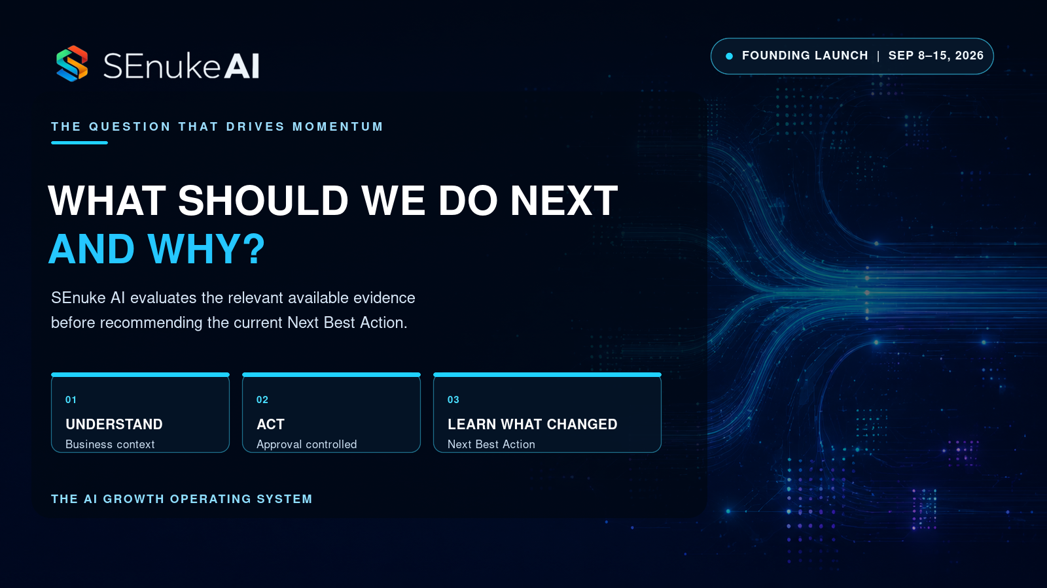
ARTICLE 03

The Business Growth Question Most Platforms Cannot Answer
SEO title | The Business Growth Question Most Platforms Cannot Answer
Meta description | Most platforms report what happened or generate more work. The harder question is what your business should do next, and why.
Suggested slug | /the-business-growth-question-most-platforms-cannot-answer/
Hero image | BLOG-HERO-003_The-Business-Growth-Question-Most-Platforms-Cannot-Answer_1600x900.png
Primary audience | Business owners, marketing leaders and growth teams
Affiliate CTA | Replace `{{AFFILIATE_LINK}}` with your approved SEnuke AI JVZoo affiliate link before publishing.

Business software is excellent at answering narrow questions.
What was our traffic? Which keywords moved? How many leads arrived? What content can we create? Which tasks are overdue? Where did users leave the funnel?
Those answers can all be useful. But they do not necessarily answer the question a business owner must eventually confront:
What should this business do next?
That question sounds simple because it fits in one sentence. In practice, it requires the platform to connect context, evidence, Strategy, effort, risk, execution and learning. Most systems can see only one part of that picture.

Reporting the past is not the same as choosing the future
Analytics describes observed behavior. It can show that traffic fell, a product page converted poorly or a campaign produced fewer enquiries than expected.
But a metric rarely explains the complete response.
A traffic decline could be caused by lost visibility, weaker demand, a technical problem, seasonality, measurement failure or a competitor change. A low conversion rate could reflect the offer, the audience, the page, the checkout experience, the price, insufficient trust or low-quality traffic.
If a platform sees only the metric, its recommendation is likely to reflect the limits of that view.
The business needs a system that can distinguish observation from inference, examine the available supporting evidence and place the finding in the context of the approved Strategy.

Creation platforms answer a different question
Generative tools often answer, “What can we make?”
They can create an article, a sequence, a landing page, a product description or a strategy document. But the ability to create something does not establish that the business should create it.
Before production begins, a stronger system should ask:
- What business goal does this support?
- What evidence shows the asset is needed?
- Is the opportunity already covered?
- Does it depend on another change?
- Is there a higher-value constraint elsewhere?
- How will the result be evaluated?
Without those questions, speed can multiply waste.

The answer must be business-specific
There is no universally correct Next Best Action.
Two businesses can have the same traffic level and need completely different responses. One may need stronger visibility. The other may already attract enough prospects but lose them through an unclear offer. A third may have a strong offer and weak follow-up. A fourth may have unreliable tracking and need to repair the evidence before making a decision.
The recommendation must reflect the current business situation, including:
- the audience and offer;
- the business model and stage;
- goals and constraints;
- location, products or services;
- available assets and channels;
- connected and supplied evidence;
- previous work and measured outcomes;
- cost, effort, urgency and risk;
- dependencies, permissions and capacity.
This is why business context cannot be an optional paragraph added to a prompt. It needs to be part of the operating system.

Evidence makes guidance defensible
A useful recommendation should not be presented as validated merely because an AI produced it confidently.
SEnuke AI evaluates the relevant available evidence before recommending the current Next Best Action. That includes checking the source, freshness and status of the evidence, separating observed facts from calculations and inference, identifying conflicts or gaps and confirming whether the opportunity has already been addressed.
The system can then explain not only what it recommends, but why.
Where relevant, the user should be able to understand the supporting evidence, confidence basis, expected impact, effort, cost, dependencies, risk and approval requirements.
If the evidence is insufficient, the system should not guess. It should explain what is missing and guide the user toward the connection, refresh, review or validation step required to move forward reliably.
Sometimes the smartest next business move is to improve the quality of the decision before increasing the size of the action.

Priority is a choice, not a list
Most audits produce recommendations. Many produce too many.
A list of 47 opportunities transfers the prioritization problem back to the customer. The business still has to decide what to fund, what to delay and what to ignore.
The Next Best Action standard is more demanding.
When several opportunities exist, SEnuke AI compares them and identifies the strongest currently supported move. Other valid opportunities remain connected to the Strategy or Execution Plan. They are not discarded, but they also do not compete equally for attention.
This creates a clearer operating question for the team: “What must happen next to move the approved priority forward?”

The answer must survive execution
A recommendation has limited value if it cannot become controlled work.
The selected priority should connect to tasks, owners, dependencies, required resources, approvals and status. Generated outputs should be reviewable and versioned. Material publishing or external changes should move forward only through the correct permissions and approval of the correct version.
Where direct implementation is supported, the approved work can proceed through that path. Where it is not, the system should provide a clear manual handoff instead of pretending that execution occurred.
This keeps guidance honest and turns Strategy into accountable action.

The answer should change when the evidence changes
The Next Best Action is not a permanent label.
After approved work is completed, results should be measured using the available evidence. The system can compare the new state with the previous one, preserve what was learned and decide whether to:
- retain the current priority;
- update or reprioritize it;
- replace it with a stronger action;
- identify a new opportunity;
- request more evidence before reaching a reliable conclusion.
This is the difference between a static plan and a continuous growth system.
SEnuke AI continues monitoring eligible supported signals while the customer is away, detects meaningful changes and reevaluates priorities. It does not use that monitoring as permission for uncontrolled external action. Approval, roles, permissions and cost controls remain in force.

Different users, the same essential question
For an Entrepreneur, “what next?” may mean deciding which business idea deserves validation.
For an established Business, it may mean choosing between acquisition, conversion, retention, ecommerce, website and operational growth opportunities.
For an Agency, it may mean identifying which client needs attention, which approval is blocking progress or which validated finding should become a proposal or client priority.
The answer changes. The standard does not.
The recommendation should be specific to the business, supported by the available evidence, aligned with Strategy, practical to execute and clear about what requires approval.

A better measure of business AI
The next generation of business software should not be judged only by how much it can generate or how many metrics it can display.
A stronger measure is whether it can help the customer make a better decision, act with control and learn from what happened.
That is why the central question matters.
Not “What can this platform do?”
What should this business do next?
SEnuke AI is built around answering that question through a guided, evidence-based Continuous Growth Loop.
Founding Launch: SEnuke AI opens September 8, 2026 at 12:00 PM ET. Founding Launch pricing ends September 15, 2026 at 11:59 PM ET. Discover your current Next Best Action.
Related reading: Turning Evidence Into the Next Best Action · How the Continuous Growth Loop Works · Why More AI Tools Do Not Mean More Growth

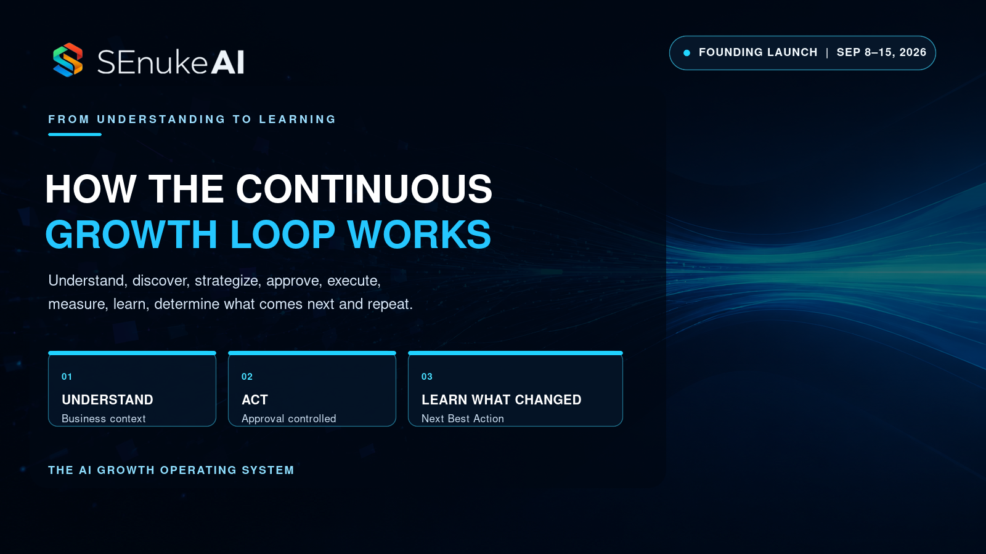
ARTICLE 04

How the Continuous Growth Loop Works
SEO title | How the Continuous Growth Loop Works in SEnuke AI
Meta description | See how SEnuke AI connects understanding, discovery, strategy, approval, execution, measurement, learning and the Next Best Action.
Suggested slug | /how-the-continuous-growth-loop-works/
Hero image | BLOG-HERO-004_How-The-Continuous-Growth-Loop-Works_1600x900.png
Primary audience | Entrepreneurs, businesses, agencies and growth teams
Affiliate CTA | Replace `{{AFFILIATE_LINK}}` with your approved SEnuke AI JVZoo affiliate link before publishing.

Most growth plans are created as if the business will stand still while the plan is being executed.
It will not.
Customers change. Competitors move. Performance rises and falls. New evidence appears. An assumption that looked reasonable in January may be wrong by March. Yet many businesses keep following a static plan because nobody has connected the results back to the decision that created the work.
The Continuous Growth Loop is designed to solve that problem.
SEnuke AI connects the complete sequence:
Understand → Discover → Strategize → Approve → Execute → Measure → Learn → Next Best Action → Repeat
The loop is not a slogan pasted over a set of tools. Each stage creates the conditions for the next one, and each completed cycle improves the context behind future decisions.

1. Understand the business before prescribing work
Growth advice becomes generic when it begins without context.
SEnuke AI starts by building the Business Brain. This preserves the information that should shape future guidance, including the audience, offer, business model, goals, market, competitors, assets, properties, constraints and previous decisions.
For an existing company, that may mean clarifying the current commercial situation and the outcome the business wants to improve.
For someone without a business, understanding begins earlier. The Entrepreneur workspace can explore skills, knowledge, experience, interests, time, budget and preferred way of working. Those inputs become the basis for realistic opportunities to compare and validate.
The purpose is not to collect information for its own sake. It is to prevent later analysis from treating every business as interchangeable.

2. Discover the opportunities and risks that matter
Once the system understands the situation, discovery can examine the relevant evidence.
Depending on the business, that can include customers, markets, competitors, search intent, website architecture, technical issues, content gaps, offers, conversion paths, local visibility, ecommerce products and categories, retention opportunities, authority signals and other supported data.
Discovery should do more than produce observations. It should identify what the observation means for the business.
A page problem may be limiting visibility. A category structure may be making products harder to find. A weak call to action may be wasting qualified attention. A competitor gap may expose an opportunity. A disconnected source may make an apparent problem impossible to validate.
The system distinguishes observed facts from calculations, estimates and AI inference, then makes the evidence status visible.

3. Strategize by making choices
A Strategy is not a list of everything that could be done.
It is an ordered view of what the business should pursue, what it should defer and how the pieces support the goal.
SEnuke AI compares opportunities using factors such as expected impact, evidence, confidence, effort, cost, urgency, risk, fit and dependency. The result is a connected Growth Blueprint rather than a collection of independent tactics.
This is where growth becomes more disciplined. The team can see why one opportunity deserves attention ahead of another and how proposed work fits the larger direction.

4. Approve before material execution
Good guidance should accelerate decisions without removing human control.
SEnuke AI allows important outputs to be reviewed, edited, revised, compared, saved and approved. Roles and permissions determine who can see, approve or execute sensitive work.
Material publishing, website changes, listing changes, outreach and other external actions remain approval-governed. Only the approved version moves forward where approval is required.
This stage prevents a common automation failure: treating an AI draft as if it were automatically safe to publish.
Approval also creates a clearer operating record. The business can distinguish a suggestion from a decision and a decision from a completed action.

5. Execute through accountable work
Strategy creates value only when it becomes action.
Approved priorities can be turned into an Execution Plan with tasks, dependencies, owners, status and approval requirements. SEnuke AI can prepare the work justified by the Strategy, including relevant website pages, landing pages, lead magnets, content, ecommerce improvements and other growth assets.
Where a supported and permissioned destination is available, the approved work can move through that execution path. Where direct writing is not available, the system provides a clear export or manual implementation handoff.
The goal is to close the space between “we know what to do” and “the work was completed,” without pretending that every destination supports the same action.

6. Measure the available result
Completion is not the finish line.
The system should determine what changed after the work was implemented. That requires a baseline, a relevant measure, compatible evidence and enough history to make a responsible comparison.
Not every action produces an immediate revenue signal. A technical correction may first affect crawlability. A new offer may need enough qualified traffic before conversion can be judged. A local improvement may need relevant visibility and customer-action evidence.
Measurement is useful when it reflects what can genuinely be observed, not when it forces certainty into incomplete data.

7. Learn from the difference between expectation and result
The learning stage connects the result to the reasoning behind the action.
Did the expected movement occur? Did another constraint become visible? Was the hypothesis wrong? Did the work create a new opportunity? Is the data still too limited to decide?
SEnuke AI preserves that learning so the next recommendation is not made as if the previous cycle never happened.
This matters because growth compounds through better decisions, not merely through more activity.

8. Determine the current Next Best Action
After the evidence is updated, the system reevaluates the priority.
It may retain the existing Next Best Action, refine it, replace it with a stronger move, identify a new opportunity or request the evidence required for a reliable decision.
The recommendation is validated against the current Business Brain, approved Strategy, evidence, previous work, results, constraints, dependencies, permissions and available capacity.
Where relevant, SEnuke AI explains what it found, why it matters, why the recommendation has priority and what the customer should do next.

9. Repeat without starting over
The final step is what turns the sequence into an operating system.
SEnuke AI continues monitoring eligible supported signals while the customer is not logged in. It records fresh evidence, detects meaningful change and reevaluates whether the current priority still makes sense.
The system does not erase human control. Monitoring and learning can update guidance, but material external execution still respects approval, roles, permissions and cost controls.
The business returns to a system that remembers the context and can explain what changed, rather than to a blank chat window waiting for another prompt.

Why the loop is stronger than a campaign
A campaign has a beginning and an end. A business does not.
Campaigns remain useful, but they should live inside a system that connects them to the company’s larger goals and learns from their results. Otherwise, each launch, content sprint, website project or optimization effort risks becoming an isolated event.
The Continuous Growth Loop creates continuity across those efforts.
For an Entrepreneur, it can connect an early idea to validation, launch work and the first evidence of what the market responds to.
For a Business, it can connect multiple people and growth activities around one current priority.
For an Agency, it can keep each client’s context, Strategy, approvals, execution and reporting isolated while giving the agency a consistent delivery model.

Growth becomes a system when learning changes what happens next
The defining feature of the loop is not repetition alone. Repeating the same work without learning is just routine.
The loop becomes valuable when evidence changes the decision.
That is how SEnuke AI connects strategy to action and action to a smarter Next Best Action.
Founding Launch: SEnuke AI opens September 8, 2026 at 12:00 PM ET. Founding Launch pricing ends September 15, 2026 at 11:59 PM ET. See the Continuous Growth Loop in action.
Related reading: What Is an AI Growth Operating System? · Turning Evidence Into the Next Best Action · Why Established Businesses Need One Shared Growth System

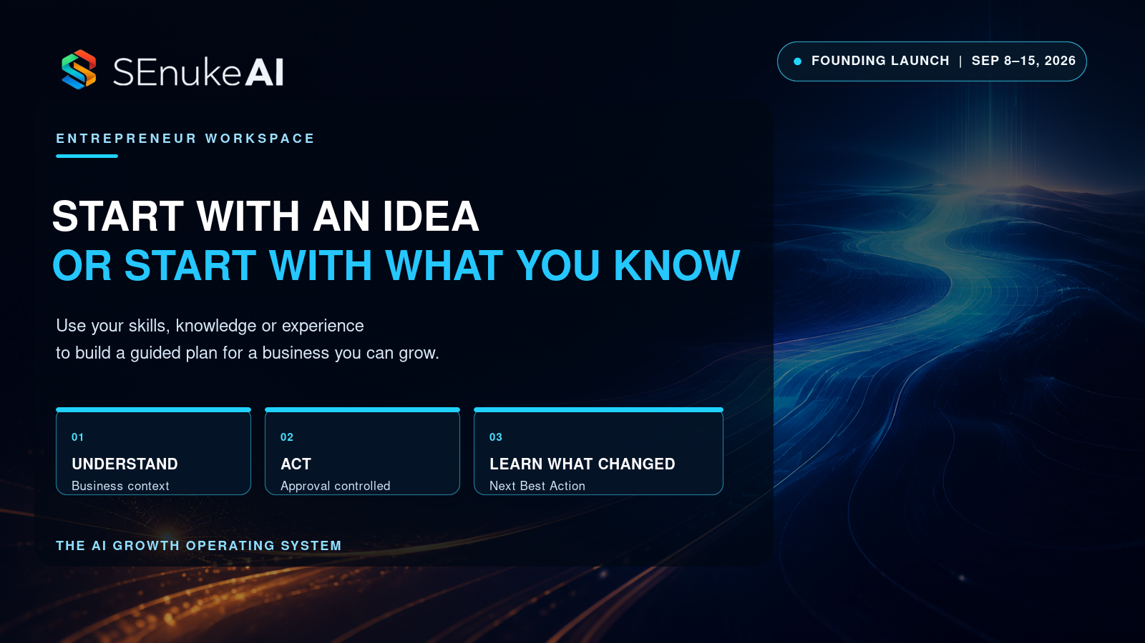
ARTICLE 05

From Idea or Expertise to a Business You Can Grow
SEO title | From Idea or Expertise to a Business You Can Grow
Meta description | You do not need a finished business to start. Learn how to turn an idea, skill or area of expertise into a direction you can validate and grow.
Suggested slug | /from-idea-or-expertise-to-a-business-you-can-grow/
Hero image | BLOG-HERO-005_From-Idea-Or-Expertise-To-A-Business-You-Can-Grow_1600x900.png
Primary audience | Aspiring entrepreneurs, creators, freelancers, consultants and owner-operators
Affiliate CTA | Replace `{{AFFILIATE_LINK}}` with your approved SEnuke AI JVZoo affiliate link before publishing.

The pressure to find the perfect business idea keeps many capable people from starting at all.
They assume they need a breakthrough concept, a polished offer, a website and a complete plan before they can take the first serious step. Meanwhile, the raw material for a viable direction may already exist in what they know, what they have done and what other people repeatedly ask them to help with.
The answer is not to declare every skill profitable. It is to turn personal experience into business possibilities, then examine those possibilities before committing heavily.
That is a discovery and validation problem, not a motivation problem.

You can begin before you have a business
SEnuke AI’s Entrepreneur workspace is designed for a person building or growing a business of their own. That includes someone who has:
- no business and no clear idea;
- an early idea that needs validation;
- skills, knowledge or experience they want to turn into an offer;
- a freelance, consulting, creator, affiliate or service business;
- a local operation;
- a small ecommerce, dropshipping or third-party marketplace business.
You do not need a finished company, website, audience or Strategy before you begin.
The starting point can be an idea. It can also be your skills, experience, interests, constraints, time, budget and preferred way of working.

Start with evidence about you
Business discovery often begins with market trends and ignores the person who must actually build the business.
A promising market is not automatically a suitable business. The practical fit depends on the founder’s capabilities, access, motivation, resources and tolerance for complexity.
Useful starting questions include:
- What have you learned deeply enough to explain or apply?
- What problems have you solved in work, life or a specialist interest?
- What do people already ask you for help with?
- Which audiences do you understand from direct experience?
- What assets, credentials, relationships or access do you already have?
- How much time and budget can you realistically commit?
- Do you prefer services, products, education, ecommerce or another delivery model?
- Which constraints must the business respect?
These answers do not produce a guaranteed winner. They produce better inputs for generating realistic options.

Turn raw experience into opportunity hypotheses
A skill is not yet a business. It becomes commercially interesting when it connects to a defined audience, a meaningful problem and a way to deliver value.
For example, “I understand bookkeeping” is a capability. Possible business directions could involve a specialist service for a particular customer type, a training product for new operators, a systemized cleanup offer or a resource that solves a recurring problem.
SEnuke AI can help translate what the user knows into opportunity hypotheses, then compare considerations such as:
- audience and problem;
- offer and delivery model;
- customer and commercial intent;
- competitive alternatives;
- difficulty and operational requirements;
- likely risks and dependencies;
- first validation step.
The purpose is not to make the decision for the founder. It is to make the decision clearer.

Compare before you commit
Entrepreneurs often fall in love with the first idea that feels exciting. A better process creates room to compare.
SEnuke AI allows possibilities to be saved, rejected, refined and compared in a Discovery Draft or Idea Brief before they become formal projects. This separates exploration from execution.
That distinction protects the founder from two costly extremes:
- treating every thought as a business that deserves a website and months of work;
- dismissing promising ideas because they are not fully formed on day one.
Comparison should consider more than market size. The strongest current direction may be the one with the best fit between a real customer problem, credible founder advantage, reasonable complexity and a practical route to validation.

Validate the assumption that matters most
No software can guarantee that a business will succeed. It can help the user identify which assumptions need evidence before the commitment grows.
The first validation step may involve customer conversations, intent research, a simple offer test, competitor analysis, a landing page, a small service pilot, a product-category investigation or another evidence-gathering action appropriate to the idea.
SEnuke AI evaluates the relevant available evidence and explains what it found, what remains uncertain and what the founder should consider doing next.
If the evidence is weak or contradictory, the system should not promote the idea as proven. Resolving the gap may become the current Next Best Action.
That can save months of building around an assumption nobody tested.

Move from an idea to a Business Brain
Once the founder is ready to proceed, the chosen direction can become a project with a Business Brain.
The system preserves the audience, offer, market, goals, competitors, assets, constraints and evidence behind the decision. That context then shapes the Strategy, website, search work, content, lead generation, conversion assets and measurement.
The founder no longer has to re-explain the business to disconnected tools or ask each one for an isolated answer.
This matters especially in the early stages, when positioning and priorities can change quickly. The work stays connected to the current business direction rather than to an outdated prompt.

Build through the Continuous Growth Loop
Starting a business is not a single launch event. It is a sequence of decisions that become more informed as evidence arrives.
SEnuke AI guides the user through:
Understand → Discover → Strategize → Approve → Execute → Measure → Learn → Next Best Action → Repeat
That can mean choosing an audience, validating an offer, building the first conversion path, creating an approved asset, measuring the response and deciding what deserves attention next.
The current Next Best Action keeps the process focused. The founder does not need to understand every internal tool or decide which analysis to run next. The system connects the available intelligence and makes the next logical move clear.

Ecommerce is part of the Entrepreneur path
The opportunity does not have to be a traditional service or information product.
Ecommerce is available in every SEnuke AI workspace. An Entrepreneur can investigate product, category and niche opportunities, examine commercial and buyer intent, improve buyer-facing product and category information, and identify merchandising, bundle, upsell, cross-sell or conversion priorities where the relevant evidence is available.
Third-party sellers can use public, crawlable and user-supplied information to improve listing clarity, positioning and competitive understanding. When a direct supported connection is unavailable, the system provides guided implementation steps rather than pretending to control the marketplace account.

The Entrepreneur plan is the complete system
Entrepreneur is not a stripped-down trial of the real product.
Every paid plan receives the complete core AI Growth Operating System. Entrepreneur is the owner workspace, with 2,000 monthly AI Capacity, for a person building or growing a business of their own.
Founding Launch pricing is $79 monthly or $790 annually. The Business and Agency plans add greater capacity and operating structure for teams and client work.

You do not need certainty. You need a better next step.
The goal of discovery is not to eliminate every risk before starting. That would be impossible.
The goal is to replace vague hope with a business hypothesis, compare it intelligently, validate the assumption that matters and make the next commitment proportionate to the evidence.
You may already have more to build from than you think.
SEnuke AI helps turn that raw material into a guided path from possibility to Strategy, action, learning and the next decision.
Founding Launch: Entrepreneur is $79 monthly or $790 annually during the SEnuke AI Founding Launch. The event ends September 15, 2026 at 11:59 PM ET. Start with your idea, skills or experience.
Related reading: What Is an AI Growth Operating System? · Turning Evidence Into the Next Best Action · Ecommerce Growth Beyond More Listings and More Traffic

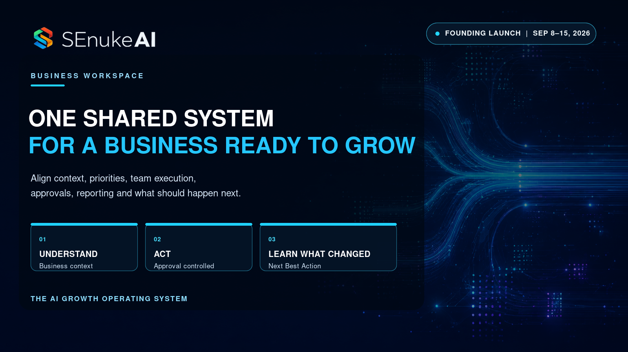
ARTICLE 06

Why Established Businesses Need One Shared Growth System
SEO title | Why Established Businesses Need One Shared Growth System
Meta description | Established businesses rarely need more activity. They need shared context, clearer priorities, controlled execution and learning across the company.
Suggested slug | /why-established-businesses-need-one-shared-growth-system/
Hero image | BLOG-HERO-006_Why-Established-Businesses-Need-One-Shared-Growth-System_1600x900.png
Primary audience | Business owners, marketing leaders, operators and teams
Affiliate CTA | Replace `{{AFFILIATE_LINK}}` with your approved SEnuke AI JVZoo affiliate link before publishing.

Established businesses are rarely short of activity.
Campaigns are running. Content is being produced. The website has a backlog. Sales wants more leads. Operations wants better customers. Someone is reviewing analytics. Someone else has a new AI tool.
The company can look busy from every angle and still leave the most important growth constraint untouched.
The problem is not effort. It is that customer intelligence, marketing activity, website work, offers, conversion data, tasks and results often live in separate systems with separate owners. Each team sees part of the business, but nobody has a reliable shared answer to what deserves priority now.
That is why an established company needs a shared growth system.

Tool sprawl becomes decision sprawl
Adding specialized tools can improve individual functions. It can also create competing versions of reality.
The SEO platform says visibility is the problem. The content calendar says production is behind. Paid media says the offer needs more traffic. Analytics points to a conversion drop. Sales reports poor lead quality. Customer success sees a retention issue.
Any one of those observations may be valid. The company still needs to determine which problem is the constraint, which evidence is reliable and which action should come first.
Without a shared operating layer, that decision is made through meetings, persuasion and incomplete context. The loudest dashboard or stakeholder can win even when another opportunity has stronger evidence and impact.

One Business Brain creates shared context
SEnuke AI begins by preserving the business context behind the work.
The Business Brain connects the audience, offer, goals, market, competitors, properties, assets, constraints, approved decisions and available evidence. Teams do not have to rebuild that understanding every time they analyze a problem or produce an asset.
Shared context improves more than consistency. It improves relevance.
A content recommendation can reflect the actual offer and audience. A conversion opportunity can be evaluated against the acquisition strategy. A website change can be checked against work already underway. A new idea can be compared with current priorities rather than added automatically to the backlog.

Find the real growth constraint
More awareness is not always the answer.
A company may already attract enough attention but lose value through a weak offer, poor conversion path, unclear product structure, low activation, retention gaps or missed upsell and cross-sell opportunities.
SEnuke AI can examine the relevant customer, market, website, search, offer, funnel, ecommerce and performance evidence to identify where the strongest current opportunity appears to be.
The system then compares possible actions by expected impact, evidence, effort, cost, urgency, dependency and risk.
This changes the conversation from “What should marketing produce next?” to “What is currently limiting growth, and what action is best supported?”

Turn the Strategy into accountable execution
Many strategy documents are thoughtful and commercially useless. They describe a direction but do not govern the work.
SEnuke AI connects the Strategy to an Execution Plan. Priorities can become tasks with owners, dependencies, status and approval requirements. Important outputs can be reviewed, revised, versioned and approved before they move forward.
Roles and permissions protect control. Team members can contribute without every person receiving the same authority. Material publishing, website changes and other external actions remain governed by the correct approval and permission.
The business gains a clearer record of what was proposed, what was approved, what was completed and what is still blocked.

Use evidence to allocate attention and budget
Every company has finite capacity.
That includes team time, management attention, cash, publishing bandwidth and AI Capacity. A serious growth system should make the cost of action visible before resources are committed.
SEnuke AI surfaces relevant effort, cost, dependencies, risks and capacity requirements alongside the recommendation. This helps the business compare not only the theoretical upside of an idea, but the practical case for acting on it now.
The strongest move is not always the largest project. It may be a focused repair that removes a constraint from work the company is already doing.

Keep teams aligned without handing control to automation
Businesses want the speed of AI without the risk of uncontrolled action.
SEnuke AI is guided. It explains what it found, why it matters, what it recommends and why that recommendation has priority. It can prepare approved work and support execution through available permissioned destinations.
But guidance does not bypass governance.
The correct user still reviews sensitive outputs. The approved version remains distinct from a draft. Roles determine who can act. Cost controls and capacity apply. When a direct implementation route is unavailable, the system provides a clear handoff rather than claiming that a change was made.
This allows a company to move faster without turning the brand, website or customer experience over to an unsupervised process.

Connect acquisition, conversion and customer value
Growth becomes distorted when every function optimizes its own metric.
Acquisition can increase traffic that does not convert. Content can increase output without supporting the offer. Conversion work can raise an immediate metric while attracting poor-fit customers. Retention issues can remain hidden because the reporting ends at the lead.
A shared growth system allows the business to examine the complete commercial journey where reliable data is available:
- awareness and demand;
- search and discovery;
- audience and offer fit;
- website and conversion paths;
- leads, purchases or activation;
- retention, reactivation and referral;
- upsells, cross-sells and customer value.
The goal is not to force every signal into one simplistic score. It is to connect the evidence well enough to make a stronger decision.

Ecommerce teams benefit from the same shared system
For an ecommerce business, the growth constraint may appear anywhere from category discovery to checkout.
SEnuke AI can help identify product and category opportunities, improve product information and site architecture, examine merchandising and buyer intent, and evaluate conversion, cart, checkout and revenue evidence when compatible data is available.
The work stays connected to the same Business Brain, Strategy, approval process and measurement loop as the rest of the company. Ecommerce does not become another isolated stack.

Replace the static plan with continuous learning
An annual plan begins aging the day it is approved.
SEnuke AI’s Continuous Growth Intelligence monitors eligible supported signals while the customer is away, detects meaningful change and reevaluates the current Next Best Action. Completed work and measured outcomes become part of the reasoning behind the next priority.
The system may retain the current action, update it, replace it or request more evidence. It does not have to wait for the next quarterly planning meeting to notice that the situation changed.

The Business workspace
The SEnuke AI Business workspace is for a company growing its own organization. It includes the complete core AI Growth Operating System with 5,000 monthly AI Capacity and the structure required for greater activity, collaboration, roles and approvals.
Founding Launch pricing is $147 monthly or $1,470 annually.
The value is not simply more AI usage. It is a shared operating system that helps the company understand the business, choose the strongest current priority, coordinate approved work and learn from the result.

Busy is not the same as growing
The strongest companies do not win because they create the longest backlog.
They improve their ability to see the constraint, choose deliberately, execute with control and update the decision when new evidence arrives.
That is the job of a shared growth system.
Founding Launch: Business is $147 monthly or $1,470 annually during the SEnuke AI Founding Launch. The event ends September 15, 2026 at 11:59 PM ET. Connect your company around one growth system.
Related reading: Why More AI Tools Do Not Mean More Growth · How the Continuous Growth Loop Works · Turning Evidence Into the Next Best Action

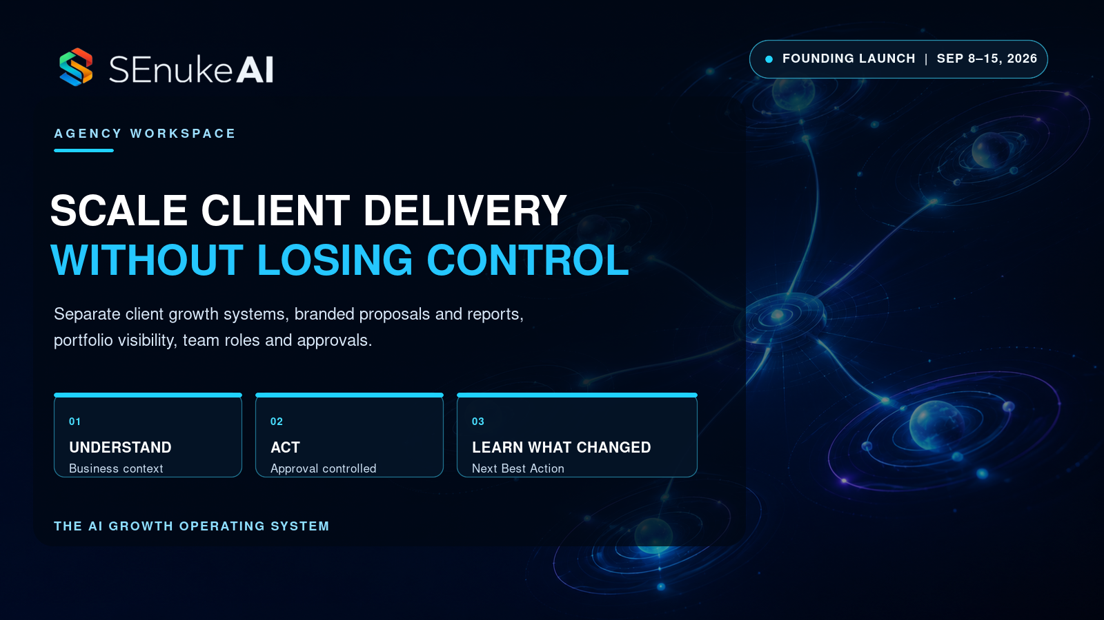
ARTICLE 07

How Agencies Scale Clients Without Losing Control
SEO title | How Agencies Scale Client Growth Without Losing Control
Meta description | Learn how agencies can scale research, strategy, execution, approvals, proposals and reporting while keeping every client isolated.
Suggested slug | /how-agencies-scale-clients-without-losing-control/
Hero image | BLOG-HERO-007_How-Agencies-Scale-Clients-Without-Losing-Control_1600x900.png
Primary audience | Agency owners, consultants, freelancers and client-service teams
Affiliate CTA | Replace `{{AFFILIATE_LINK}}` with your approved SEnuke AI JVZoo affiliate link before publishing.

Agency growth creates an uncomfortable paradox.
Winning more clients should make the business stronger. Yet every new account adds research, context, deliverables, approvals, reporting, meetings and risk. Revenue grows, but so does the amount of invisible coordination required to keep the work credible.
Eventually the agency owner faces a choice that should not be necessary: protect quality by limiting growth, or accept more clients and tolerate delivery chaos.
A better operating model can change that equation.
The goal is not to automate away agency judgment. It is to give the agency one repeatable growth system while preserving the independent context, evidence, permissions and history of every client.

Scale the method, not the client data
Agencies need consistency. Clients need specificity.
Those requirements are compatible when the agency standardizes the operating process without mixing the information inside it.
SEnuke AI Agency uses an Agency → Client → Project structure. Each client has a separate Business Brain, intelligence, Strategy, Execution Plan, integrations, approvals, activity history and reporting.
The agency can apply the same disciplined method across accounts:
Understand → Discover → Strategize → Approve → Execute → Measure → Learn → Next Best Action → Repeat
But the recommendation for one client is grounded in that client’s situation. One company’s data, decisions and work do not become another company’s context.
That is how an agency scales a strategic standard without turning its service into generic output.

Preserve knowledge beyond the account manager
Client context often lives inside people.
An account manager remembers the rejected offer. A strategist knows why a campaign changed. A specialist understands which data source is unreliable. When that knowledge is scattered across calls, notes and individual tools, the agency becomes vulnerable to handoffs and staff changes.
The Business Brain preserves the client’s audience, offer, goals, market, competitors, properties, constraints, assets and approved decisions. Previous work and results remain connected to the ongoing Strategy.
The next person entering the account does not have to reconstruct the client from a folder of documents and a meeting recording. The system retains the context required for relevant guidance.

See the portfolio without flattening the clients
Agency owners need to manage by exception.
They should be able to see which clients need attention, where an approval is blocking progress, which reports are due, where a connection or evidence problem exists and how shared capacity is being used.
That does not mean reducing every account to one misleading score. It means surfacing the operational signals that require action while preserving the client-specific detail underneath them.
SEnuke AI’s Agency workspace provides portfolio visibility across client and project work. The agency can see priorities and status at the command level, then move into the isolated client system when judgment is required.
This reduces the need to inspect every account manually just to discover where the problem is.

Coordinate delivery through roles and approvals
Agency work involves more than the agency owner and a platform.
Strategists, specialists, editors, account managers and clients may all need different access. A person who can prepare work should not necessarily be able to publish it. A client who can review a shared report should not see internal cost or another client’s information.
SEnuke AI supports role-controlled work, permissions, assigned tasks, approval routing, activity history and client-safe visibility.
Important outputs can be edited, revised, versioned and approved. Material live actions remain governed by the correct role, permission and approval of the correct version.
The agency gains speed without surrendering control of the client relationship.

Turn validated intelligence into stronger proposals
Proposal preparation can consume hours before the agency knows whether the prospect will buy.
The usual shortcuts create risk. A generic template fails to demonstrate understanding. An automated audit may overstate a problem. A rushed scope may blend assumptions with evidence.
SEnuke AI can use validated prospect or client findings to prepare an editable, agency-branded proposal draft. The agency remains responsible for the commercial decision. It adds or edits the scope, timeline, pricing, add-ons, terms and assumptions.
The proposal can connect the observed situation to a recommended direction without inventing findings, outcomes or fees. Branded PDF output and proposal status make the sales process easier to manage and present professionally.
The result is not a robot closing the deal. It is an agency entering the conversation with a stronger, evidence-fed case and full control of what it is offering.

Make delivered value easier to see
Agencies do not lose clients only because the work failed.
They also lose clients when valuable work becomes difficult to understand.
A report filled with metrics can still leave the client asking, “What did you do, what changed and why does it matter?”
SEnuke AI supports branded, client-friendly reporting that connects available performance evidence with explanation, completed work, limitations, opportunities and the current Next Best Action. The agency can edit the narrative, approve it and provide a professional PDF for download or manual sharing.
The Client Viewer can give the client permission-safe access to explicitly shared client material for their own account.
Clear reporting does not guarantee retention. It does make the agency’s reasoning, work and current priority easier for the client to understand.

Improve capacity without pretending people are unnecessary
Agency margin is often lost in repetitive synthesis.
Teams repeatedly gather the same categories of context, translate findings into plans, convert plans into tasks, assemble reports and explain what should happen next. A connected system can reduce that repeated coordination.
SEnuke AI helps the agency spend less effort moving information between disconnected tools and more effort applying judgment, serving the client and improving the Strategy.
This is not a claim that the platform replaces account management, specialists or leadership. The agency still owns the relationship, the commercial choices, quality and approval.
The benefit is leverage: a stronger operating method supported by connected intelligence and guided work.

Serve different business models in one agency workspace
An agency may serve a local professional, a service company, a SaaS business and an ecommerce brand at the same time.
Each client can have a distinct audience, offer, market, evidence model and growth constraint. Ecommerce intelligence is available inside Agency client workspaces, including product and category opportunities, buyer-intent research, merchandising priorities and conversion analysis when reliable data is available.
The agency does not need one generic playbook masquerading as strategy. It can maintain a consistent operating framework while allowing the evidence to produce different priorities for different clients.

Keep client priorities current
Static account plans become stale between reporting cycles.
SEnuke AI’s Continuous Growth Intelligence monitors eligible supported signals, detects meaningful changes and reevaluates the client’s current Next Best Action while the agency team is away. New evidence can retain, update or replace the priority.
Monitoring does not authorize uncontrolled client changes. Roles, approvals, permissions, cost controls and version history still govern execution.
The agency can return to a clearer view of what changed and which account deserves attention.

The Agency workspace
SEnuke AI Agency is designed for agencies, consultants and freelancers growing businesses on behalf of clients. It includes the complete core AI Growth Operating System, the Agency → Client → Project operating structure, two included team seats and 18,000 shared monthly AI Capacity.
Founding Launch pricing is $497 monthly or $4,970 annually.
The agency does not need to choose between growth and control. It needs a system that makes both easier to manage.
Founding Launch: Agency is $497 monthly or $4,970 annually during the SEnuke AI Founding Launch. The event ends September 15, 2026 at 11:59 PM ET. Explore SEnuke AI Agency.
Related reading: What Is an AI Growth Operating System? · How the Continuous Growth Loop Works · Turning Evidence Into the Next Best Action

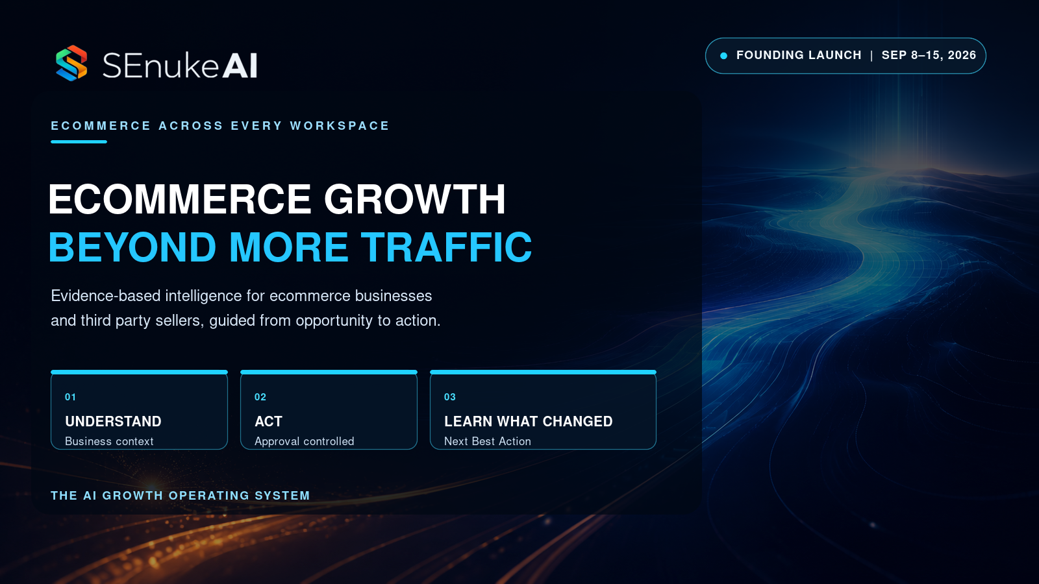
ARTICLE 08

Ecommerce Growth Beyond More Listings and More Traffic
SEO title | Ecommerce Growth Beyond More Listings and More Traffic
Meta description | Ecommerce growth is not always about adding products or buying traffic. Learn how evidence reveals stronger product, merchandising and conversion priorities.
Suggested slug | /ecommerce-growth-beyond-more-listings-and-more-traffic/
Hero image | BLOG-HERO-008_Ecommerce-Growth-Beyond-More-Listings-And-Traffic_1600x900.png
Primary audience | Store owners, ecommerce teams, dropshippers and third-party marketplace sellers
Affiliate CTA | Replace `{{AFFILIATE_LINK}}` with your approved SEnuke AI JVZoo affiliate link before publishing.

When ecommerce growth slows, the default response is usually more.
More products. More listings. More content. More ads. More traffic.
Sometimes more is justified. Sometimes it sends a larger audience into the same weak buying experience.
The strongest growth opportunity may already be inside the products, categories, merchandising, offer structure or conversion path the business has today. Finding it requires the store to ask a better question than “How do we get more visitors?”
It needs to ask:
What is the current Next Best Action for this ecommerce business?

Traffic cannot repair every problem
A store can attract attention and still underperform.
Potential buyers may land on a category that does not reflect how they shop. Product titles may hide the most important differentiator. Descriptions may list features without resolving the buyer’s concern. Internal links may fail to connect discovery pages to commercial pages. Bundles and cross-sells may ignore natural purchase relationships. Trust or checkout friction may stop an otherwise qualified customer.
Sending more traffic into those problems increases cost without necessarily increasing value.
A growth system should examine the available evidence across discovery, product understanding, merchandising and purchase behavior before deciding that acquisition deserves the next investment.

Begin with product and category opportunity
Ecommerce intelligence can help a business understand what buyers seek, how they describe the need and where current products or categories may fail to match that intent.
SEnuke AI can evaluate product, category and niche opportunities using relevant public, crawlable, user-supplied and supported connected evidence.
That work can reveal questions such as:
- Is buyer demand organized differently from the current category structure?
- Are important product attributes missing from titles or descriptions?
- Does the store have overlapping pages competing for the same intent?
- Are high-intent needs unsupported by a useful category, comparison or buying guide?
- Is the opportunity strong enough to justify a new product test or category investment?
The result is not a guaranteed winning product. It is a more evidence-based basis for deciding what to test, improve or defer.

Improve what buyers see and understand
A product page does more than rank. It helps the buyer decide.
SEnuke AI can help identify improvements to product and category titles, descriptions, metadata, schema, architecture and internal linking. The recommended work should reflect the customer, intent, offer and Strategy rather than producing interchangeable copy at scale.
Clarity matters because ecommerce decisions often depend on details that the seller assumes are obvious.
What is the product for? Who is it best suited to? How is it different? What concern does it resolve? What does the buyer need to know before choosing? Which related category or product should be considered next?
Improving those answers can strengthen both discoverability and the buyer journey.

Treat merchandising as growth strategy
Ecommerce growth is not limited to individual product pages.
Merchandising determines how products work together and how customers move through the range. A store may have opportunities to improve:
- category and collection organization;
- bundles that solve a complete need;
- relevant upsells and cross-sells;
- comparisons that make choice easier;
- complementary product discovery;
- offer structure and perceived value;
- navigation between educational and commercial content.
SEnuke AI can identify and prioritize these opportunities using the available business and buyer evidence.
The right recommendation may be to improve the path around an existing product rather than add another SKU.

Follow the buyer journey into conversion
Public information can reveal how the store presents itself. Private performance evidence is required to make reliable conclusions about what buyers actually do.
When compatible tracking or supplied data is available, SEnuke AI can examine conversion friction, cart behavior, checkout movement, purchases, revenue and customer-value signals. Margin, inventory, repeat-purchase and retention conclusions require the relevant connected or supplied evidence.
The system should make those conditions visible. It should not treat an estimate as an observed sale or claim a revenue outcome that the data cannot support.
With reliable evidence, the ecommerce team can compare acquisition opportunities with conversion and customer-value opportunities instead of assuming that traffic is always the constraint.

Third-party sellers can improve without handing over the account
Ecommerce is bigger than owned storefronts.
Amazon, Etsy, eBay, Walmart, Poshmark and other marketplace sellers also need to understand buyer intent, listing clarity, product positioning, competitive alternatives and category opportunities.
SEnuke AI can use public, crawlable and user-supplied evidence to identify relevant opportunities and recommend manual improvements. That can help a third-party seller decide what to test in a title, description, imagery brief, offer or merchandising approach.
It is important to describe the boundary clearly. SEnuke AI does not claim to take over marketplace account operations. It does not promise automated listing changes, repricing, relisting, inventory management, advertising, checkout, payments, fulfilment, returns or disputes.
The value is intelligence and guided execution: validate the relevant evidence, prioritize the opportunity and make the current Next Best Action clear.

Direct action remains controlled
When a supported store or publishing connection is available, approved work can move through the permissioned implementation path.
The exact version still requires the appropriate review and approval before a material live change. When direct writing is unavailable, SEnuke AI provides a clear export or manual handoff.
This protects the store from uncontrolled changes while reducing the distance between insight and implementation.

Ecommerce works across every SEnuke AI plan
Ecommerce is not a separate product and it is not restricted to the Business or Agency workspace.
- Entrepreneur can support a person starting or growing a store, dropshipping operation or third-party selling business. It includes 2,000 monthly AI Capacity and Founding Launch pricing of $79 monthly or $790 annually.
- Business supports an operating ecommerce company that needs greater capacity, collaboration, roles and approvals. It includes 5,000 monthly AI Capacity and Founding Launch pricing of $147 monthly or $1,470 annually.
- Agency supports ecommerce work for separate clients through the Agency → Client → Project structure. It includes 18,000 shared monthly AI Capacity and Founding Launch pricing of $497 monthly or $4,970 annually.
Every plan includes the complete core AI Growth Operating System.

Connect ecommerce work to learning
An isolated optimization can create a temporary lift without improving the team’s ability to decide what comes next.
SEnuke AI connects ecommerce intelligence to the Continuous Growth Loop:
Understand → Discover → Strategize → Approve → Execute → Measure → Learn → Next Best Action → Repeat
The system can monitor eligible supported signals, detect meaningful change and reevaluate priorities while the customer is away. It may retain the current action, update it, replace it or request stronger evidence.
Material external execution remains approval-controlled.

Sell more intelligently before simply doing more
Ecommerce growth does not have to begin with another campaign or another page of products.
It can begin by understanding where the buyer journey is weak, which opportunity is best supported and what the business should improve next.
That is a more disciplined path to selling more than treating volume as the answer to every problem.
Founding Launch: SEnuke AI opens September 8, 2026 at 12:00 PM ET. Founding Launch pricing ends September 15, 2026 at 11:59 PM ET. Find the Next Best Action for your ecommerce business.
Related reading: From Idea or Expertise to a Business You Can Grow · Why Established Businesses Need One Shared Growth System · Turning Evidence Into the Next Best Action

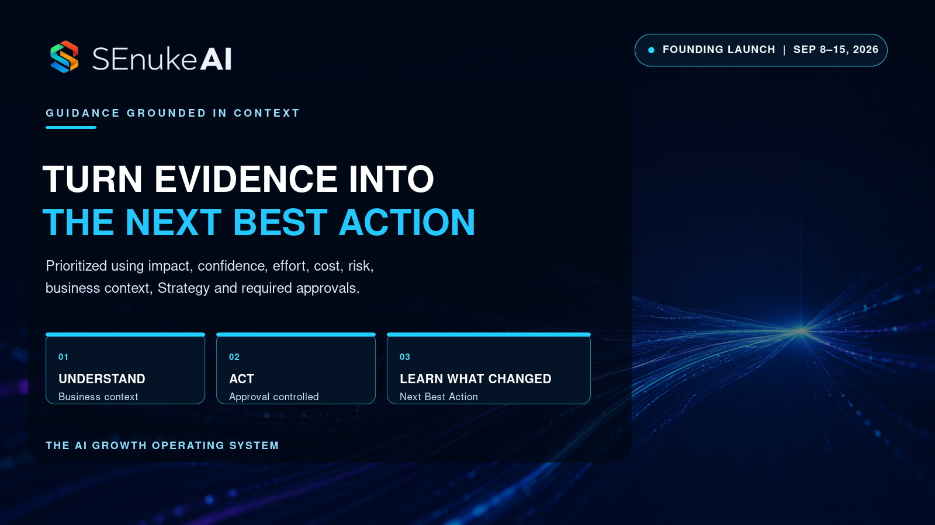
ARTICLE 09

Turning Evidence Into the Next Best Action
SEO title | Turning Business Evidence Into the Next Best Action
Meta description | Learn how SEnuke AI validates business evidence, compares opportunities and recommends the strongest current Next Best Action with human control.
Suggested slug | /turning-evidence-into-the-next-best-action/
Hero image | BLOG-HERO-009_Turning-Evidence-Into-The-Next-Best-Action_1600x900.png
Primary audience | Entrepreneurs, business owners, agencies and growth teams
Affiliate CTA | Replace `{{AFFILIATE_LINK}}` with your approved SEnuke AI JVZoo affiliate link before publishing.

Evidence does not make decisions. People and systems do.
A dashboard can show a decline. An audit can identify a problem. Customer research can expose an objection. Competitor analysis can reveal a gap. None of those automatically determines what the business should do next.
The hard work begins after the finding appears.
The business must decide whether the evidence is trustworthy, whether the issue supports the current goal, whether another opportunity has greater value and whether the proposed action is practical, affordable and safe to execute.
SEnuke AI is designed to connect that reasoning and turn the relevant available evidence into the current Next Best Action.

A finding is not yet a recommendation
Suppose a website page loses visibility.
That is an observation. The cause may be technical, competitive, seasonal, structural, content-related or connected to the reliability of the measurement itself.
“Rewrite the page” is a recommendation. It becomes defensible only after the system has examined enough evidence to support that response over the alternatives.
This distinction protects the business from a common form of false speed: acting immediately on the first plausible explanation.
SEnuke AI separates observed facts, calculations, estimates and AI inference. It then checks how the finding fits the Business Brain and approved Strategy before presenting it as a priority.

Validation begins with the evidence itself
Before recommending an action, the system should ask whether the supporting information is usable.
Relevant checks can include:
- Does supporting evidence exist?
- What is the source?
- Is the source connected and available?
- How fresh is the evidence?
- Is the status complete, stale, failed or partial?
- Are compatible periods being compared?
- Is another source in conflict?
- Is the apparent change large enough to be meaningful?
- Has the business already addressed the issue?
A platform that hides these questions may produce cleaner-looking recommendations, but it also makes the confidence harder to judge.
When evidence is stale, contradictory or insufficient, SEnuke AI explains the gap. It can request a connection, refresh, confirmation or review, and make resolving the uncertainty the current Next Best Action when that is the strongest supported move.

Business context changes the meaning of the evidence
The same finding can have different commercial importance for different businesses.
A keyword decline on a page that drives high-value qualified enquiries may deserve urgent attention. The same decline on an outdated topic with no strategic role may not.
A store with healthy demand and weak product-page clarity may prioritize conversion work. A new seller without enough private performance history may need to begin with public buyer-intent and listing evidence. An agency may need to repair a client connection before it can make a reliable reporting claim.
SEnuke AI validates the recommendation against relevant Business Brain information, including the audience, offer, location, products, services, business stage, goals, constraints and approved Strategy.
Evidence becomes useful when the system can explain what it means here, not merely what it usually means.

Opportunities must compete for priority
A growing business can have several valid opportunities at once.
The website may need technical work. The offer may be unclear. A category may have commercial potential. A retention issue may be reducing customer value. A competitor may have created a new gap.
If every finding becomes urgent, priority disappears.
SEnuke AI compares opportunities using factors such as:
- expected impact;
- evidence strength and confidence;
- alignment with goals and Strategy;
- effort and cost;
- urgency;
- dependencies;
- operational and reputational risk;
- available AI Capacity or Content Capacity;
- required roles, permissions and approval.
The system identifies the strongest current Next Best Action while retaining other valid opportunities in the Strategy or Execution Plan.
This gives the business focus without pretending the rest of the opportunity landscape no longer exists.

The Next Best Action can be a prerequisite
Business guidance becomes untrustworthy when it feels compelled to recommend a dramatic action.
Sometimes the most valuable next move is preparation.
The system may need the user to clarify the offer, confirm a goal, connect a data source, approve a Strategy, review a draft, resolve a permission or collect enough evidence for a reliable comparison.
That is still a Next Best Action. It is the action that makes the next substantive decision possible.
This keeps the system guided at every stage without manufacturing a conclusion from information it does not have.

A recommendation should explain itself
The customer should not have to reverse-engineer why the platform chose one action over another.
Where relevant, SEnuke AI explains:
- what it is doing;
- what it found;
- why the finding matters;
- what opportunity or risk exists;
- what it recommends;
- why the recommendation has priority;
- the expected impact;
- the supporting evidence;
- the confidence level and its basis;
- the estimated effort, cost or capacity requirement;
- dependencies, risks or limitations;
- what can be prepared or executed;
- what requires review or approval;
- what the customer should do next.
This does not guarantee that every conclusion is perfect. It makes the reasoning inspectable and gives the customer a stronger basis for judgment.

Recommendation is not permission
The Next Best Action is a validated recommendation. It is not permission for uncontrolled autonomous execution.
Material publishing, website changes, listing changes, outreach, local profile changes and other external or reputation-sensitive actions continue to respect:
- user approval;
- workspace roles and permissions;
- capacity and cost controls;
- publishing safeguards;
- version and approval history;
- the exact permissions of available integrations.
Only the approved version moves forward where approval is required.
When a direct supported execution path is unavailable, SEnuke AI provides a clear manual handoff. It does not claim that the action occurred.

Measurement turns action into learning
After approved work is completed, the system evaluates the available result and compares it with the previous evidence.
That learning can cause SEnuke AI to:
- retain the current Next Best Action;
- reprioritize or refine it;
- replace it with a stronger move;
- identify a new opportunity;
- request additional evidence when the result is not yet reliable.
The recommendation remains current because it is connected to what happened, not frozen at the moment the original Strategy was written.

Continuous intelligence keeps the decision alive
SEnuke AI continues monitoring eligible supported signals while the customer is not logged in. It records fresh evidence, detects meaningful change, avoids duplicate findings and reevaluates the current priority.
The customer can return to a system that knows what changed and whether the previous Next Best Action still deserves attention.
Monitoring remains evidence-limited and permission-aware. It updates guidance; it does not bypass approval for material external execution.

The standard applies to every workspace
The evidence and operating structure change by customer, but the decision standard remains consistent.
- Entrepreneur: compare an idea, audience, offer, website, ecommerce opportunity or early growth priority using the founder’s situation and available evidence.
- Business: connect company-wide context, teams, acquisition, conversion, retention, ecommerce and performance evidence around the strongest current constraint.
- Agency: validate client-specific findings, maintain client isolation, coordinate approvals and turn evidence into delivery priorities, reports or editable proposals.
Every plan includes the complete core AI Growth Operating System.

Better evidence should create a better decision
The purpose of business intelligence is not to create more charts.
It is to improve what the business does because of what it learned.
SEnuke AI connects evidence, Strategy, approved execution, measurement and learning so the customer can see the current Next Best Action and understand why it deserves priority.
That is how data becomes direction.
Founding Launch: SEnuke AI opens September 8, 2026 at 12:00 PM ET. Founding Launch pricing ends September 15, 2026 at 11:59 PM ET. Turn your business evidence into a clearer next move.
Related reading: The Business Growth Question Most Platforms Cannot Answer · How the Continuous Growth Loop Works · What Is an AI Growth Operating System?

